Classroom Language: Use English, please!

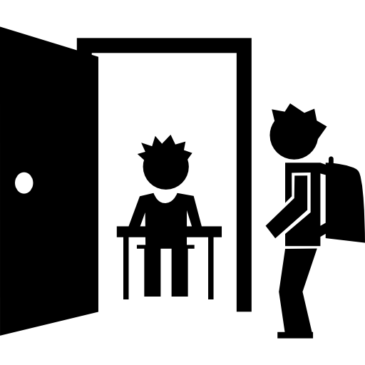
ENTERING THE CLASSROOM:

- Good morning everybody! / Hello everyone!

- How are you today? / How are you doing?

- I’m sorry I’m late / Sorry for being late

- May I come in? / Can I come in?

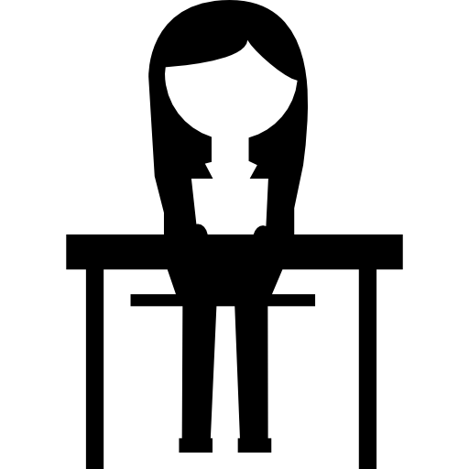
GETTING STARTED:

- What are we doing today? / What do we have to do now ?

- Where are we? / What page / activity are we on?

- I did the homework yesterday I’m sorry, but I haven’t done my homework (because…)

- I forgot the handout/worksheet at home. Could I have an extra copy, please?

- We don’t have enough handouts / worksheets. Can you give us (2) more, please?

- I don’t have my crayons here. What should I do? Can we share?

- Can I borrow a pen / your glue / Could you give me a sheet of paper, please?

- I missed class last week / I was absent last class. What should I do to catch up?

ASKING FOR PERMISSION:

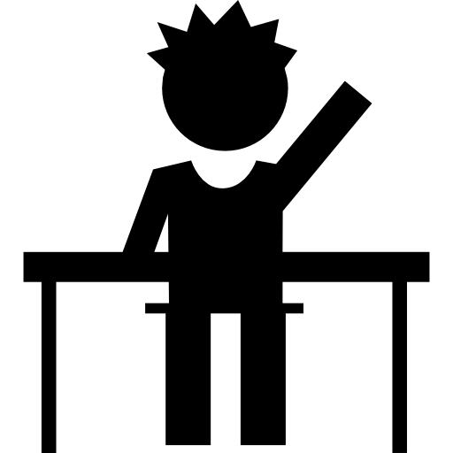
- Can I go to the bathroom / restroom, please?

- May I open/close the window? Do you want me to erase the board?

- Should I pull up / pull down the blinds? Should I turn on / turn off the lights?

- Is it OK if I sharpen my pencil now?

- I’m ready. Should I start? / I’m done. Can I read?
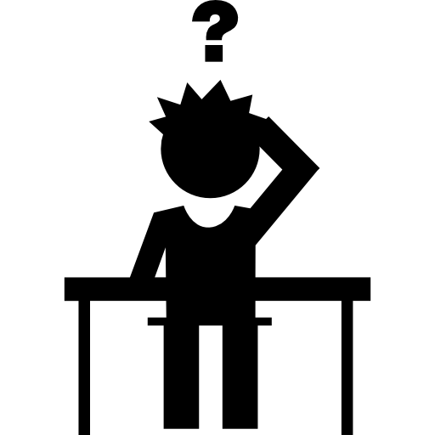
ASKING FOR CLARIFICATION:

- Sorry, I didn’t catch that! / Sorry, I missed the question

- Could you repeat that / the last part, please?

- Can you say that again (more slowly/ with other words) ?

- I still don’t understand the instructions (for the activity / lab)

- We are not sure what we’re supposed to do / I don’t get it!

- I’m sorry, but I can’t hear you / the video (clearly). Could you speak louder? / Can you turn the volume up / down, please?

- I’m sorry but don’t know the answer. Can I ask my partner, please?

- Excuse me, I have a question (about…) / Can you help me (with…), please?

- What does ”this word” mean? / What’s the meaning of ”this word” ?

- I don’t know how to say ”esta palabra” in English. Is ”this word” correct?

- How do you say ”this word” in Spanish/ English ? / Can you say it in Spanish?

- How do you spell ”this word”? / Can you write ”this word” on the board, please?

- How is ”this word” pronounced? / What’s the pronunciation of ”this word” ?

ASKING FOR OTHER INFORMATION:

- Do we have to hand in this exercise ? / Do we have to give it (back) to you?

- Do we need to work in pairs? I don’t have a partner. What should I do then?

- I’m done / I finished it. Can you check it out? / Is this right / correct?

- Do we have to write it / that down? / Do we need to take notes?

- Do we have to study that ? Is this going to be on the test / exam / quiz ?

- How long does it take? / How long will it take me to do all the homework ?

- How much time is left / remaining ? / I don’t have enough time to finish

- What’s the homework? / Do we have homework for next week ? Is it voluntary?

